**Practical 2**

**Creating account, repository on Github and Cloning repository in Github.**

1. **Creating Account:**

Step 1: Go to https://github.com/join in a web browser. You can use any web browser on your computer, phone or tablet to join.

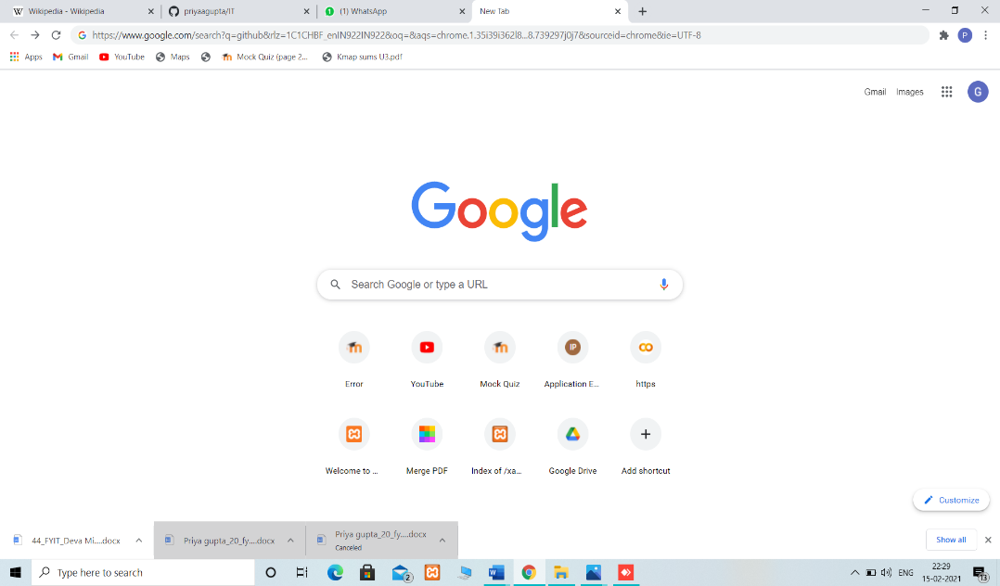

Step 2: Enter your personal details and complete the CAPTCHA puzzle.

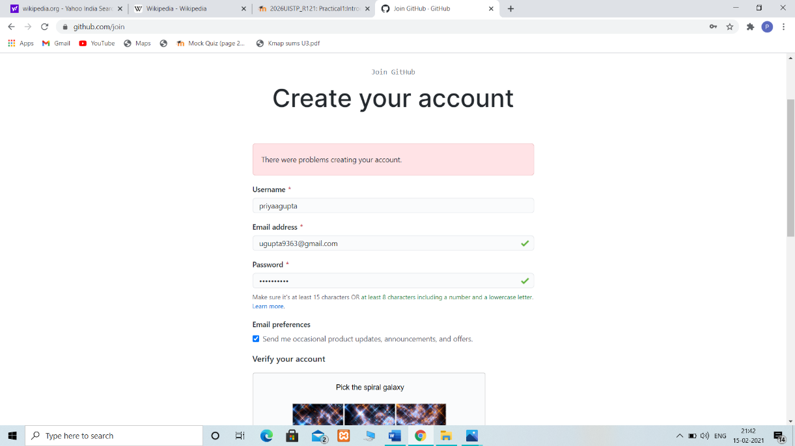

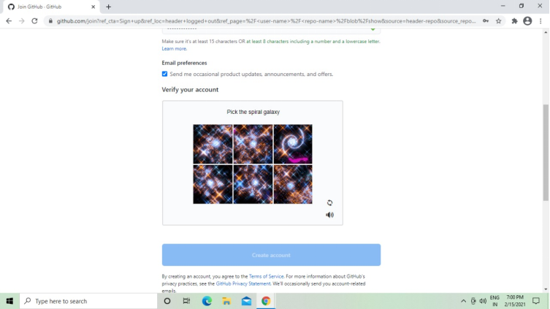

Step 3: Click the ‘Create account’ button below the form.

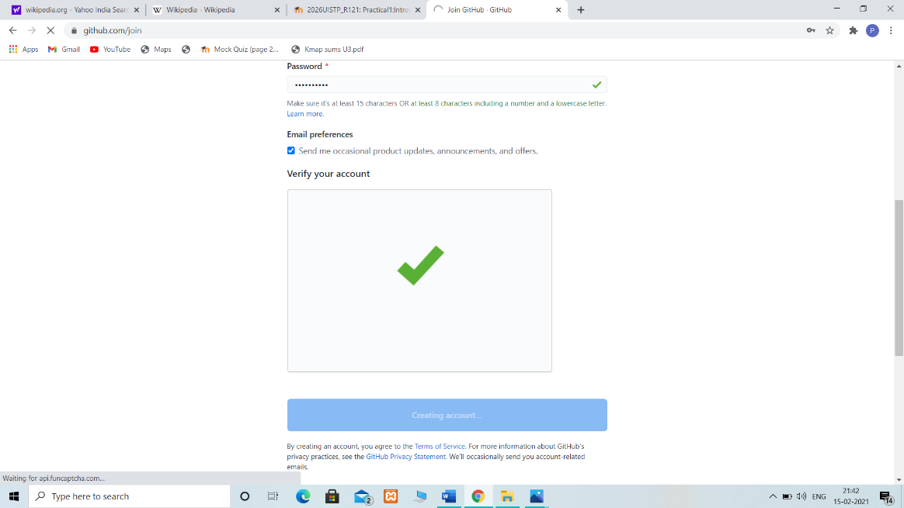

1. **Creating Repository:**

Step 1: To create repository click on + Button.

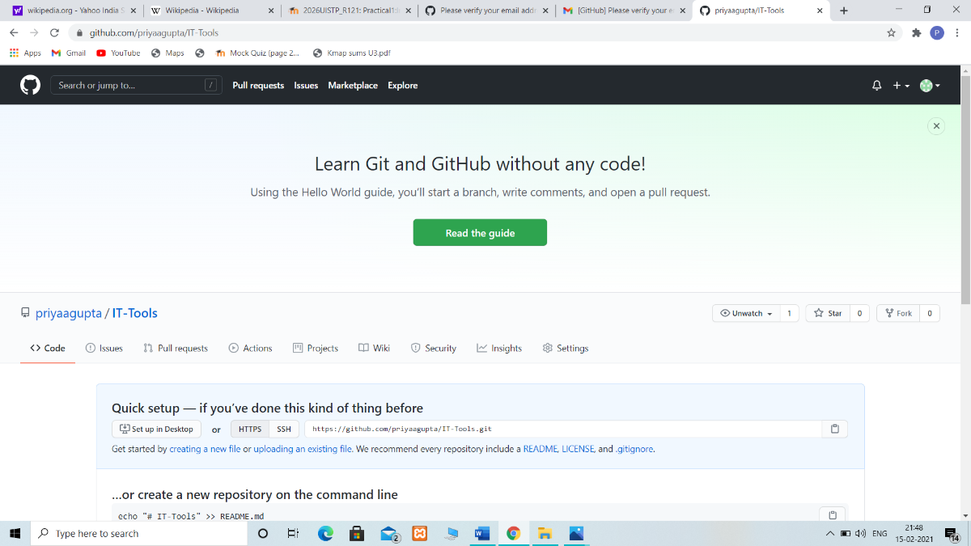

Step 2: Click on new repository.

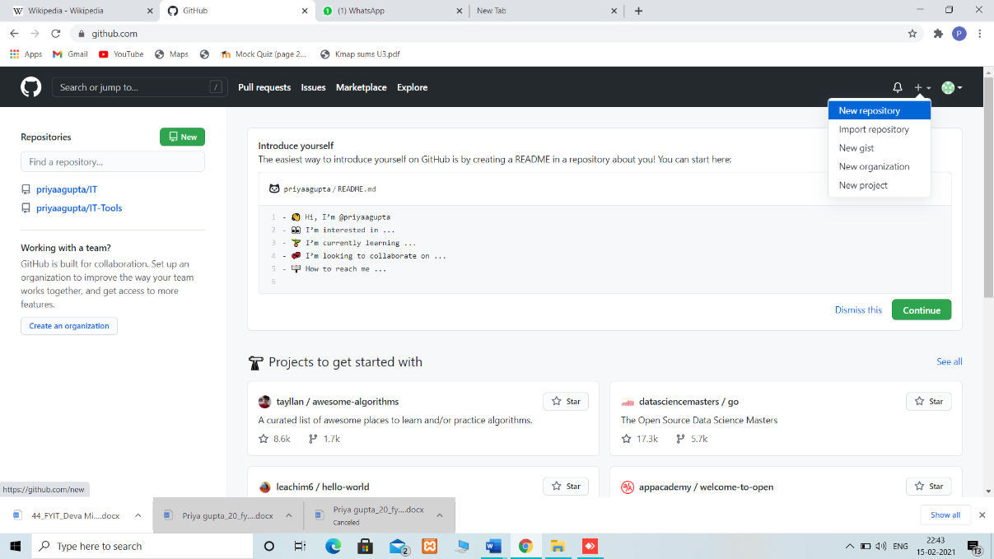

Step 3: Give name to your repository and choose one from private or public. Then click on create repository.

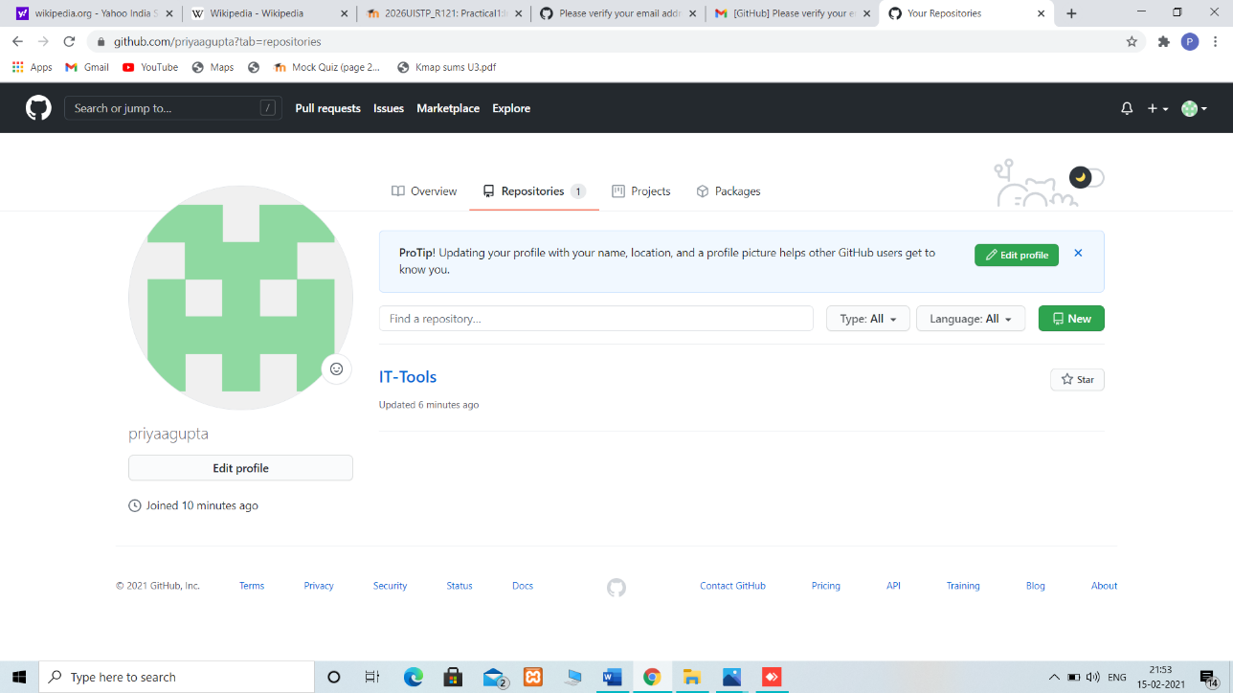

1. **Cloning Repository:**

Step 1: Click on add file button.

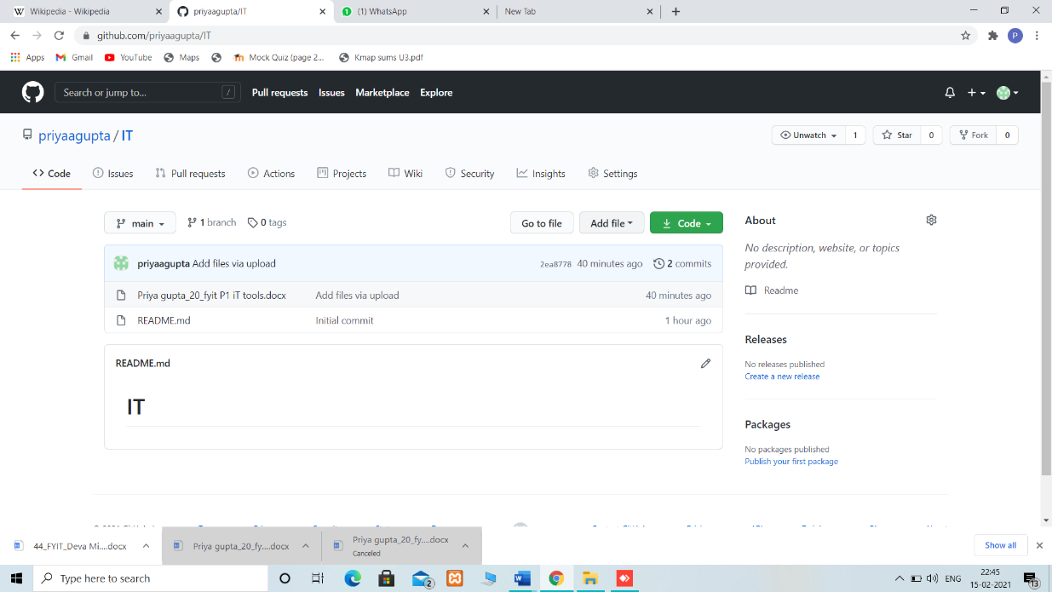

Step 2: Click on upload file button.

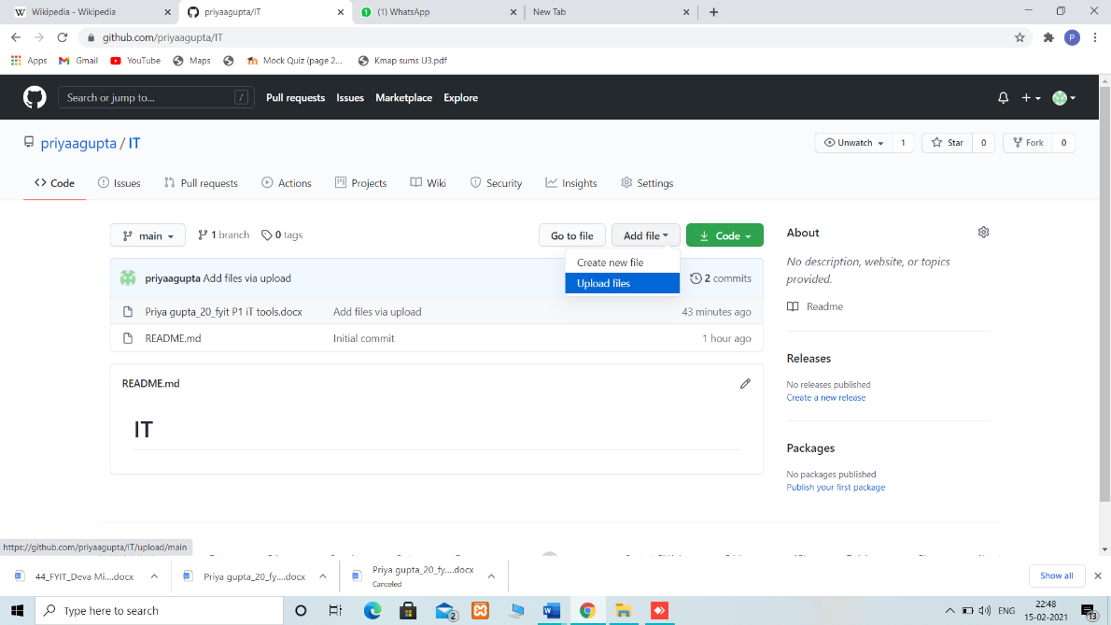

Step 3:- Click on choose your files.

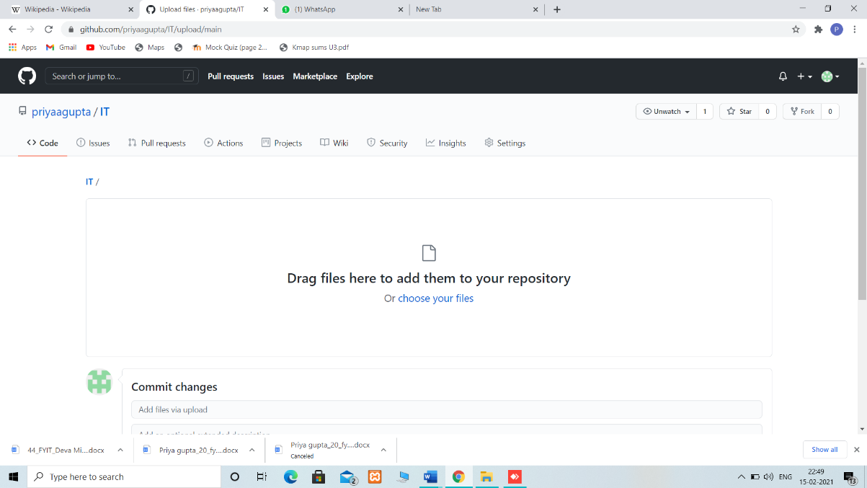

Step 4 :- Select file which you want to upload then click on open button.

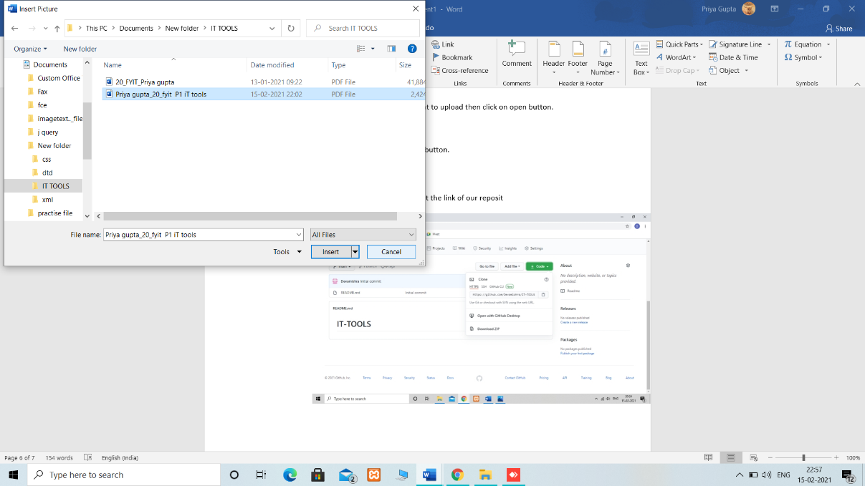

Step5 :- Click on commit changes button.

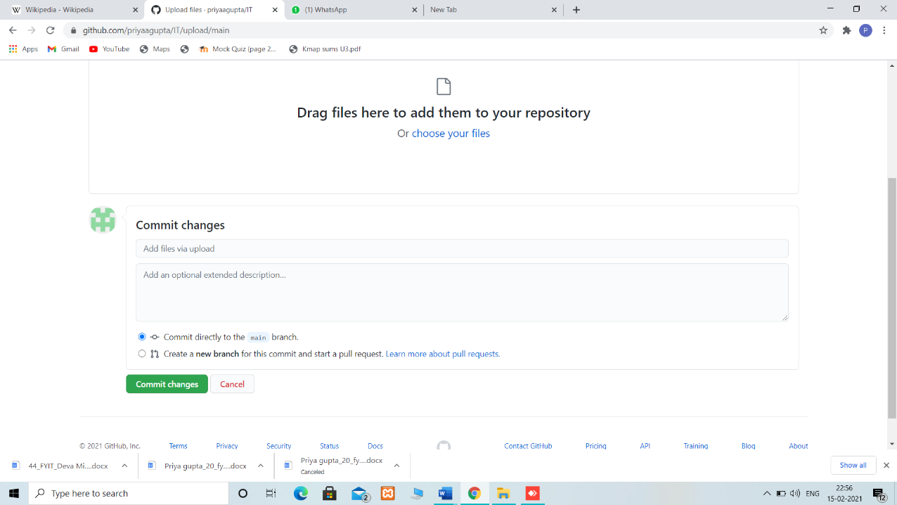

Step6:- Click on code button to get the link of our reposit

